Procedure & Instruction for filing grievance in CPGRAMS portal

Click on given link of CPGRAMS portal. Click here for PG portal. (https://pgportal.gov.in/)
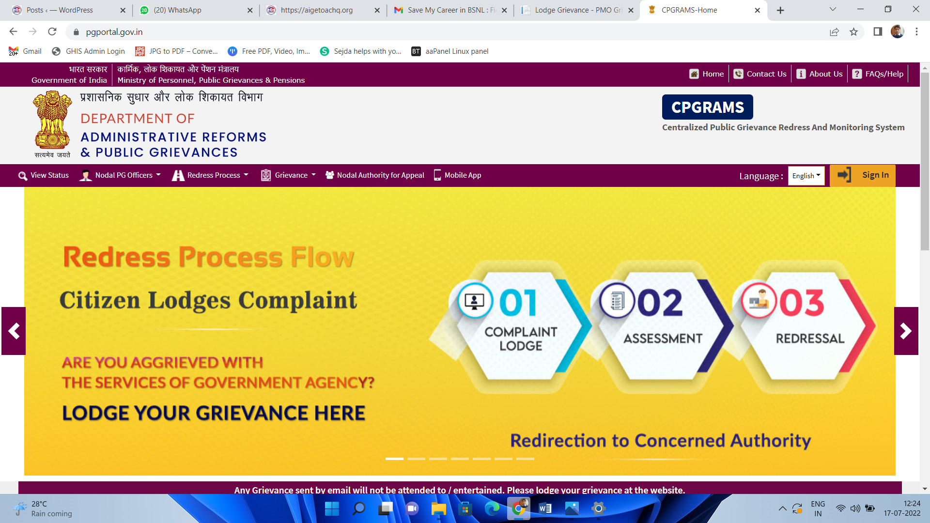
Click on Sign In and register with your mobile number OR email ID.

After log in, click on Lodge Public Grievance on left side.
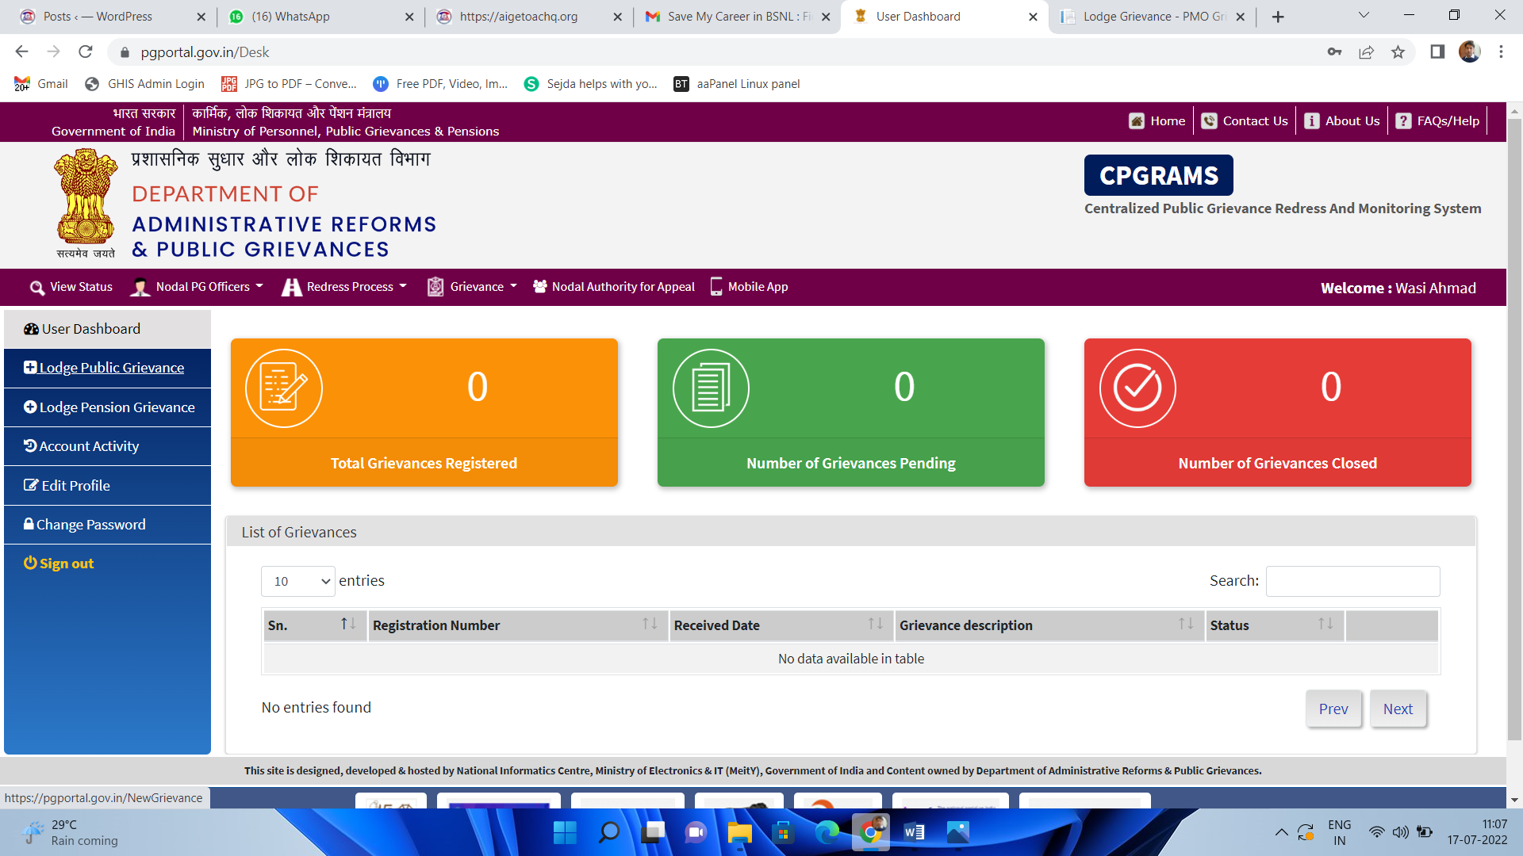
A new page will for grievance, click on box to check and submit.
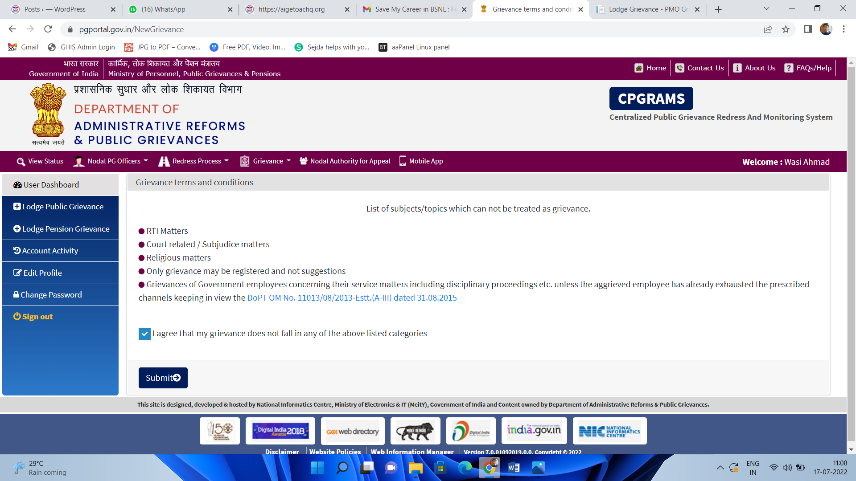
Again in new page under section Please select a Ministry/Department/State Government, Click on “Telecommunications”
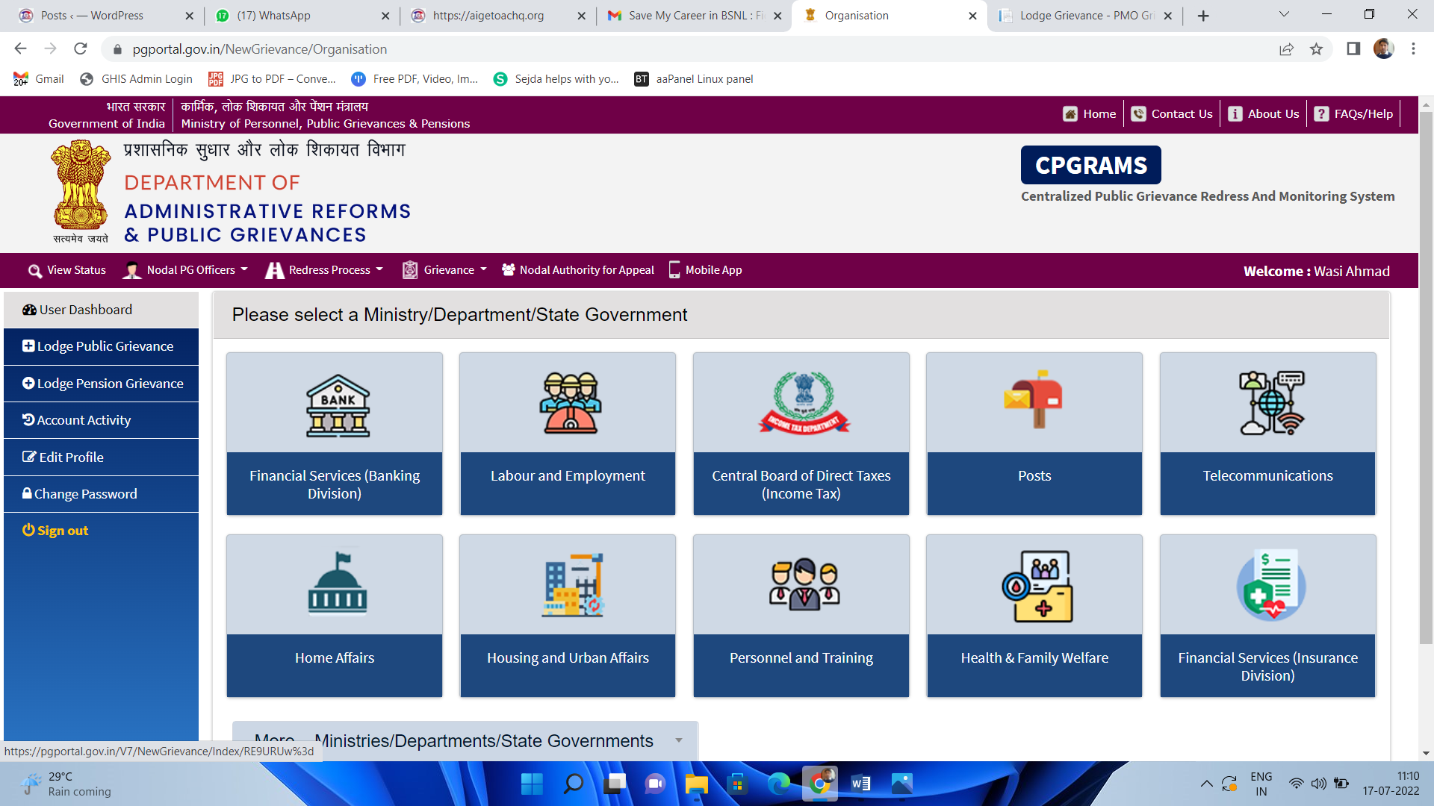
Under Telecommunications, select main category as “Employee Relate/Service Related”.
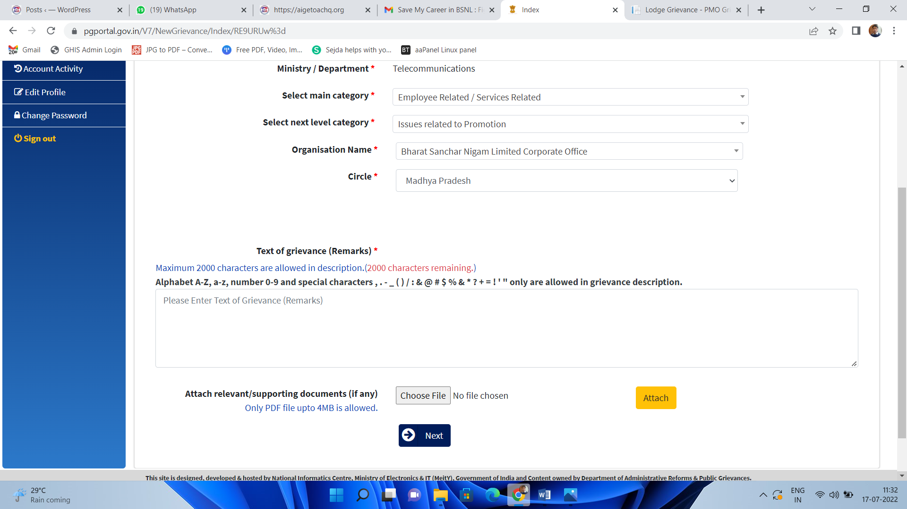
Select next level category, “Issues related to Promotion”

Organisation name, Select an Organisation name as “Bharat Sanchar Nigam Limited Corporate Office”
Under Section Circle, Select your respective Circle Name.
In Text of Grievance, Paste the Memorandum content and attach the memorandum and Click Next & Submit.

